Year 5/6 Long Term Overview
Persuade Inform Entertain Discuss
Autumn 1 | Autumn 2 | Spring 1 | Spring 2 | Summer 1 | Summer 2
Learning Journey 1 | Learning Journey 1 | Learning Journey 1 | Learning Journey 1 | Learning Journey 1 | Learning Journey 1
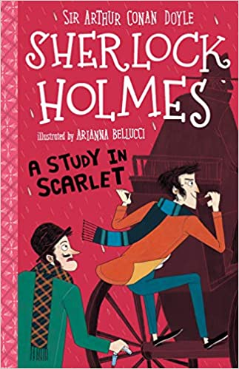  Text: Sherlock Holmes  Purpose: to entertain  Audience: children  Form: Mystery narrative | Text: Curiosity  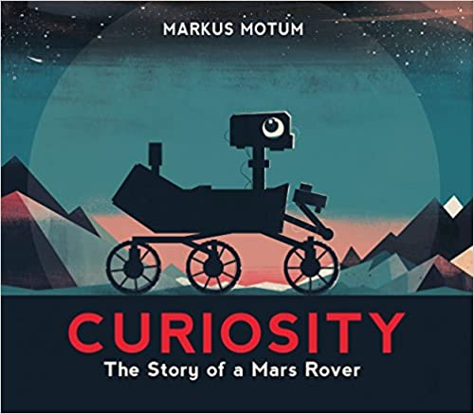  Purpose: To inform  Audience: NASA  Form: Expanded explanation for new rover | Text: The Viewer  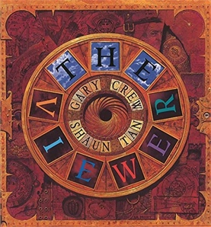  Purpose: To persuade  Audience: Character (Tristan)  Form: Letter | Text: Macbeth  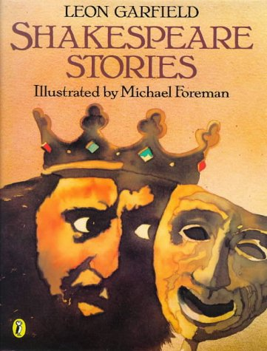  Many different writes for End of Key Stage Writing (diary entry, setting description, news report, character discussion piece, potions recipe) | Text: The Hidden Forest  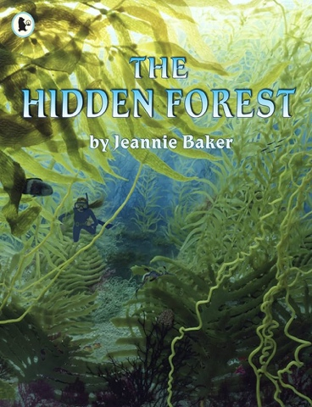 | 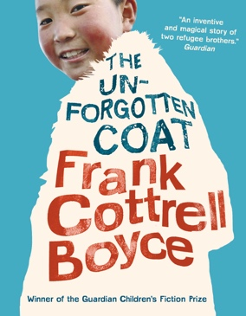  Text: The Unforgotten Coat  Purpose: To inform  Audience: New pupils who join the school from Mongolia  Form: A ‘good guide’ to our school
Grammar and punctuation  Perfect form of verbs  using expanded noun phrases to convey complicated information concisely  punctuation for speech  Writing (Composition)  in writing narratives, considering how authors have developed characters and settings in what pupils have read, listened to or seen performed  in narratives, describing settings, characters and atmosphere and integrating dialogue to convey character and advance the action  using a wide range of devices to build cohesion within and across paragraphs | Grammar and punctuation:  Using expanded noun phrases  Using hyphens to avoid ambiguity  Relative clauses  Brackets, dashes or commas to indicate parenthesis  Passive voice  Writing (Composition)  Noting and developing initial ideas, drawing on reading and research where necessary | Grammar and punctuation:  Using expanded noun phrases to convey complicated information concisely  Using commas to clarify meaning or avoid ambiguity in writing  Using hyphens to avoid ambiguity  Using brackets, dashes or commas to indicate parenthesis  Using semi-colons, colons or dashes to mark boundaries between independent clauses  Writing (Composition)  In narratives, describing settings and characters to convey character and advance the action | Grammar and punctuation:  Using semi-colons, colons or dashes to mark boundaries between independent clauses  Complex sentences  Relative clauses  Using a colon to introduce a list  Use of commas to clarify meaning or avoid ambiguity  Punctuating bullet points correctly  Writing (Composition)  Noting and developing initial ideas, drawing on reading and research where necessary  In writing narratives, considering how authors have developed characters and settings in what pupils have read, listened to or seen performed  In narratives, describing settings and characters to convey character and advance the action | Grammar and punctuation:  Modal verbs  Apostrophes  Relative clauses  Writing (Composition)  In writing narratives, considering how authors have developed characters and settings in what pupils have read, listened to or seen performed  In narratives, describing settings and characters to convey character and advance the action | Grammar and punctuation:  Modal verbs to indicate degrees of possibility  Use brackets, dashes and commas to indicate parenthesis  Writing (Composition)  Noting and developing initial ideas, drawing on reading and research where necessary
Ongoing Statements:

Writing Transcription (Spelling and Handwriting)
- Use further prefixes and suffixes and understand the guidance for adding them
- Use knowledge of morphology and etymology in spelling and understand that the spelling of some words needs to be learnt specifically, as listed in English Appendix 1
- Use dictionaries to check the spelling and meaning of words
- Use the first three or four letters of a word to check spelling, meaning or both of these in a dictionary
- Use a thesaurus

Writing Composition
- Ensure the consistent and correct use of tense throughout a piece of writing
- Use a wide range of devices to build cohesion within and across paragraphs
- Plan their writing by: - Identifying the audience for and purpose of the writing, selecting the appropriate form and using other similar writing as models for their own
- Draft and write by: - Selecting appropriate grammar and vocabulary, understanding how such choices can change and enhance meaning
- Evaluate and edit by: - Assessing the effectiveness of their own and others’ writing - Proposing changes to vocabulary, grammar and punctuation to enhance effects and clarify meaning - Proof-reading for spelling and punctuation errors
- Précising longer passages
Guided Reading | Guided Reading | Guided Reading | Guided Reading | Guided Reading | Guided Reading | Guided Reading
Text: Street Child  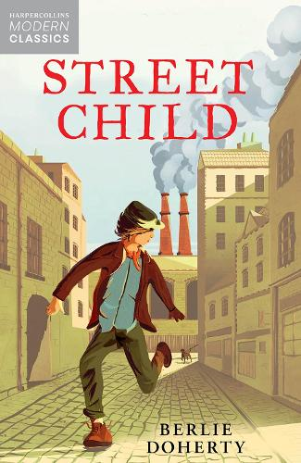 | 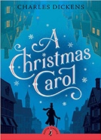  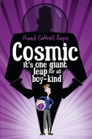 | 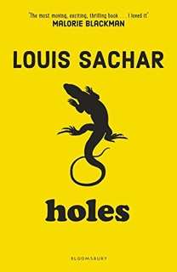  Text: Holes | Text:  The Highway Man  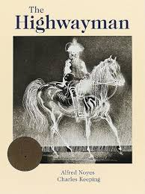 | Text: The Boy in the Tower  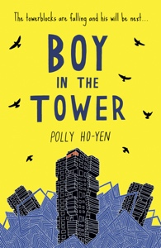 | Text: Wonder  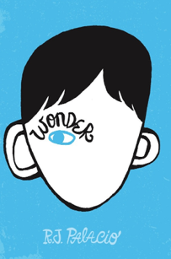
Summarising the main ideas drawn from more than 1 paragraph, identifying key details that support the main ideas  Retrieve, record and present information from non-fiction  Drawing inferences such as inferring characters’ feelings, thoughts and motives from their actions, and justifying inferences with evidence  Discuss and evaluate how author’s use language, including figurative language, considering the impact on the reader  Show understanding through intonation, tone and volume so that the meaning is clear to an audience | Summarising the main ideas drawn from more than 1 paragraph, identifying key details that support the main ideas  Drawing inferences such as inferring characters’ feelings, thoughts and motives from their actions, and justifying inferences with evidence  Identifying how language, structure and presentation contribute to meaning  Discuss and evaluate how author’s use language, including figurative language, considering the impact on the reader | Summarising the main ideas drawn from more than 1 paragraph, identifying key details that support the main ideas  Retrieve, record and present information from non-fiction  Drawing inferences such as inferring characters’ feelings, thoughts and motives from their actions, and justifying inferences with evidence  Discuss and evaluate how author’s use language, including figurative language, considering the impact on the reader  Show understanding through intonation, tone and volume so that the meaning is clear to an audience | Retrieve, record and present information from poetry  Show understanding through intonation, tone and volume so that the meaning is clear to an audience  Discuss and evaluate how author’s use language, including figurative language, considering the impact on the reader  Summarising the main ideas drawn from more than 1 paragraph, identifying key details that support the main ideas | Drawing inferences such as inferring characters’ feelings, thoughts and motives from their actions, and justifying inferences with evidence  Identifying how language, structure and presentation contribute to meaning  Summarising the main ideas drawn from more than 1 paragraph, identifying key details that support the main ideas  Discuss and evaluate how author’s use language, including figurative language, considering the impact on the reader
Ongoing statements

Apply their growing knowledge of root words, prefixes and suffixes (morphology and etymology), as listed in English appendix 1, both to read aloud and to understand the meaning of new words that they meet

Checking that the book makes sense to them, discussing their understanding and exploring the meaning of words in context

Asking questions to improve their understanding

Explain and discuss their understanding of what they have read, including through formal presentations and debates, maintaining a focus on the topic and using notes where necessary

Provide reasoned justifications for their views

Continuing to read and discuss an increasingly wide range of fiction, poetry, plays, non-fiction and reference books or textbooks

Participate in discussions about books that are read to them and those they can read for themselves, building on their own and others’ ideas and challenging views courteously

Increasing their familiarity with a wide range of books, including myths, legends and traditional stories, modern fiction, fiction from our literary heritage, and books from other cultures and traditions

Identifying and discussing themes and conventions in and across a wide range of writing

Making comparisons within and across books

